**Dr. D. Y. Patil College of Engineering and Innovation Varale, Talegaon**

**Department of Computer Engineering**

**Practical: Laboratory Practice-II**

**Class: TE Computer A.Y. 24-25 Sem-II**

# Assignment No: 4

1. **Title of Assignment:**

Implement a solution for a Constraint Satisfaction Problem using Branch and Bound / Backtracking for: A] n-queens problem B] Graph Coloring Problem

1. **Prerequisite:**

Basic knowledge of CSP, Backtracking

1. **Objective:**

In this experiment, we will be able to do the following:

* + Study how to place N queens on board with non-attacking mode using backtracking.
  + What is CSP Problem.

1. **Outcome:** Successfully able to place N queens on board with non-attacking mode using backtracking.
2. **Software and Hardware Requirement:**

Programming Languages: Python/Java

Operating System: Windows/Ubuntu

1. **Relevant Theory / Literature Survey:**

# Constraint Satisfaction Problem

**CSP means solving a problem under certain constraints or rules**

CSP depends on three components X: It is a set of variables

D: It is a set of domains

There is a specific domain for each variable.

Domain is possible values each variable can take.

C: It is a set of constraints which are followed by the set of variables. Rules that restrict how variables can be assigned.

# Backtracking Algorithm

Backtracking is an algorithmic-technique for solving problems recursively by trying to build a solution incrementally, one piece at a time, removing those solutions that fail to satisfy the constraints of the problem at any point of time (by time, here, is referred to the time elapsed till reaching any level of the search tree).

# A] n-Queens problem

The n-Queens problem is a puzzle of placing exactly N queens on an NxN chessboard, such that no two queens can attack each other in that configuration. Thus, no two queens can lie in the same row, column or diagonal.

The idea is to place queens one by one in different columns, starting from the leftmost column. When we place a queen in a column, we check for clashes with already placed queens. In the current column, if we find a row for which there is no clash, we mark this row and column as part of the solution. If we do not find such a row due to clashes then we backtrack and return false.

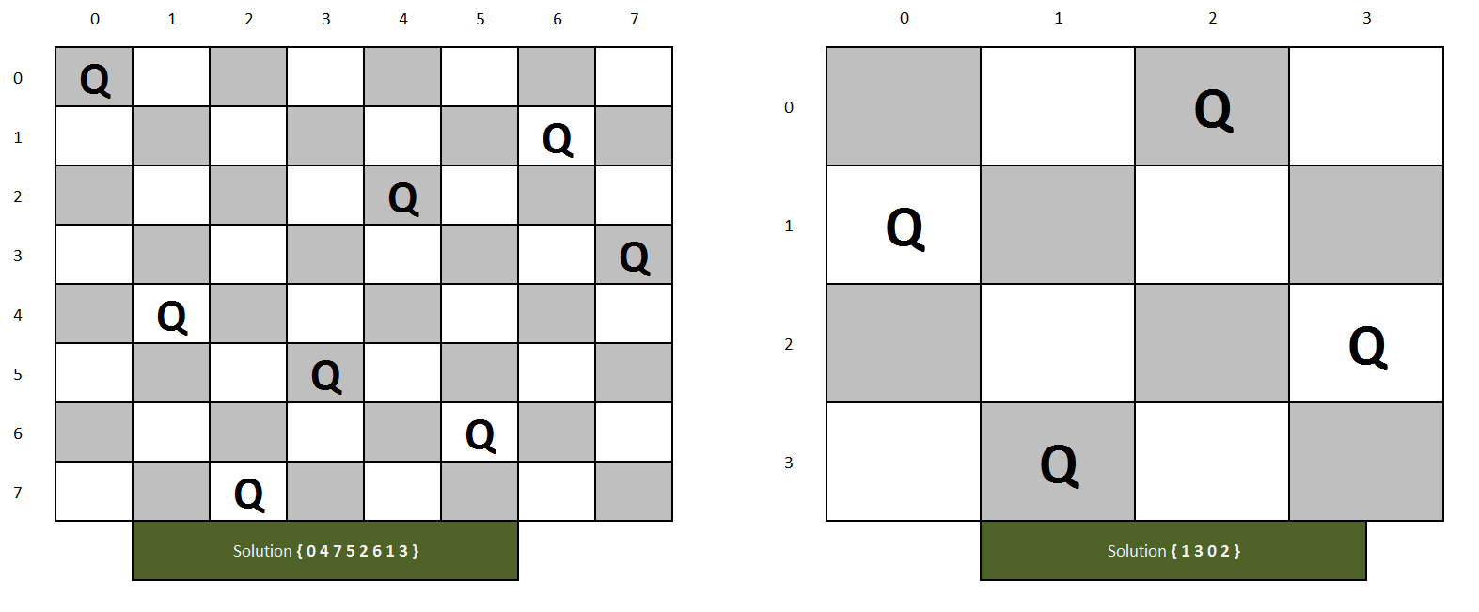

# N-Queens problem Algorithm

1. Start in the leftmost column
2. If all queens are placed return true
3. Try all rows in the current column. Do the following for every tried row.
   1. If the queen can be placed safely in this row then mark this [row, column] as part of the solution and recursively check if placing the queen here leads to a solution.
   2. If placing the queen in [row, column] leads to a solution then return true.
   3. If placing queen doesn't lead to a solution then unmark this [row, column] (Backtrack) and go to step (a) to try other rows.
4. If all rows have been tried and nothing worked, return false to trigger backtracking.

# B] Graph-Coloring Problem

# Graph Colouring is a classic Constraint Satisfaction Problem (CSP) where the goal is to assign colours to vertices of a graph such that:

# No two adjacent vertices share the same colour (edge constraint).

# Minimize the number of colours used (optional optimization).

# Formulating Graph Coloring as a CSP

# Variables (V): Each vertex of the graph is a variable.

# Domain (D): A set of available colors (e.g., {Red, Green, Blue}).

# Constraints (C): If two vertices are connected by an edge, they must have different colors.

# Example: Colouring a Graph

# Consider the following graph:

# A ----- B

# | / |

# | / |

# C ----- D

# Step 1: Define the CSP Components

# Variables (V): A, B, C, D

# Domain (D): {Red, Green, Blue}

# Constraints (C):

# A ≠ B

# A ≠ C

# B ≠ C

# B ≠ D

# C ≠ D

# Step 2: Solve the Graph Coloring CSP

# We will use the Backtracking algorithm to assign colors:

# Assign A = Red.

# For B, valid options: {Green, Blue}. Choose B = Green.

# For C, valid options: {Green, Blue}. Choose C = Blue.

# For D, valid options: {Red, Blue} (since B = Green). Choose D = Red.

# Solution: A = Red, B = Green, C = Blue, D = Red.

# Step 3: Techniques for Solving Graph Colouring CSP

# Backtracking: Explore all possibilities and backtrack if a conflict occurs.

# Forward Checking: After assigning a colour, eliminate invalid options for adjacent vertices.

# Minimum Remaining Values (MRV): Choose the vertex with the fewest legal colour option

# Branch and Bound

Branch and bound is an algorithm design paradigm which is generally used for solving combinatorial optimization problems. These problems are typically exponential in terms of time complexity and may require exploring all possible permutations in the worst case. The Branch and Bound Algorithm technique solves these problems relatively quickly.

|  |  |  |
| --- | --- | --- |
| **Parameter** | **Backtracking** | **Branch and Bound** |
| Approach | Backtracking is used to find all possible solutions available to a  problem. When it realizes that it has made a bad choice, it undoes the last choice by backing it up. It searches the state space tree until it has found a solution for the problem. | Branch-and-Bound is used to solve optimization problems. When it realizes that it already has a better optimal solution that the pre-solution leads to, it abandons that pre-solution. It completely searches the state space tree to get an optimal solution. |
| Traversal | Backtracking traverses the state space tree by [DFS (Depth First](https://www.geeksforgeeks.org/depth-first-traversal-for-a-graph/) [Search)](https://www.geeksforgeeks.org/depth-first-traversal-for-a-graph/) manner. | Branch-and-Bound traverse the tree in any manner, DFS or [BFS](https://www.geeksforgeeks.org/breadth-first-traversal-for-a-graph/). |
| Function | Backtracking involves a feasibility function. | Branch-and-Bound involves a bounding function. |
| Problems | Backtracking is used for solving Decision Problems. | Branch-and-Bound is used for  solving the optimization Problem. |
| Searching | In backtracking, the state space tree is searched until the solution is obtained. | In Branch-and-Bound as the  optimum solution may be present anywhere in the state space tree, so the tree needs to be searched completely. |
| Efficiency | Backtracking is more efficient. | Branch-and-Bound is less efficient. |
| Applications | Useful in solving [N-Queen Problem](https://www.geeksforgeeks.org/n-queen-problem-backtracking-3/), [Sum of subset](https://www.geeksforgeeks.org/subset-sum-backtracking-4/). | Useful in solving [Knapsack](https://www.geeksforgeeks.org/0-1-knapsack-using-branch-and-bound/)  [Problem](https://www.geeksforgeeks.org/0-1-knapsack-using-branch-and-bound/), Traveling Salesman Problem. |

## **7. Questions:**

**Q. 1:** Which are the constraints required to solve the N- Queens Problem?

**Q. 2:** Explain Graph Coloring problem with Example

**Q. 3:** Compare Backtracking and branch and bound methods.

**Q. 4**: What do you mean by Constraint satisfaction problem?

**8.** **Conclusion:** In This way we have studied how to solve the CSP problem and how to place N queens on board with non-attacking mode using backtracking. Also studied how to solve Graph Coloring problem